Materiality Assessment

So far in this course series, we have seen the role that ESG plays in contributing to a more sustainable and responsible future through stories and case studies, the barriers it encounters and the mindset change that you need to understand to implement it.
Would you know where to look for information to develop an ESG initiative? What are the tools and questions that you need to apply? When developing an ESG initiative, you need to consider the concept of materiality and be able to answer the right questions to develop a Materiality Assessment.
What Should a Materiality Assessment Include?
These are the questions that you need to answer when developing a Materiality Assessment:
- Who are the relevant parties?
- Do the relevant parties include employees, suppliers, customers and communities?
- Do we need to consider influence in terms of impact on the economy, the environment and people?
- Is influence purely financial, in terms of costs or compliance?
- Are the relevant parties only financial decision-makers such as investors and financiers?
- How must influence be interpreted?
Which Relevant Parties Do You Need to Consider?
Let’s consider the first element in a Materiality Assessment: the relevant parties.
Critical ESG elements for an organization are characterized by “double materiality”, which means organization impact on both stakeholders and business.
- Impact to relevant parties - Impact Materiality
  - It reflects the organizations most significant impacts on the economy, environment, and society.
  - The primary audience are Customers, Community, Employees, and Investors.
- Impact to the business - Financial Materiality
  - It's likely to impact the financial condition or operating performance of a company (i.e., substantively influence the assessments and decisions of stakeholders).
  - The primary audience are Investors and Company's Leadership.
How Can We Define a Material Issue?
There are many positions on what constitutes a material issue. Various definitions regarding materiality are presented by influential organizations such as the US SEC, ISSB, GRI, and The European Financial Reporting Advisory Group (EFRAG), who's role is to ensure that International Financial Reporting Standards are responsive to European needs and concerns.
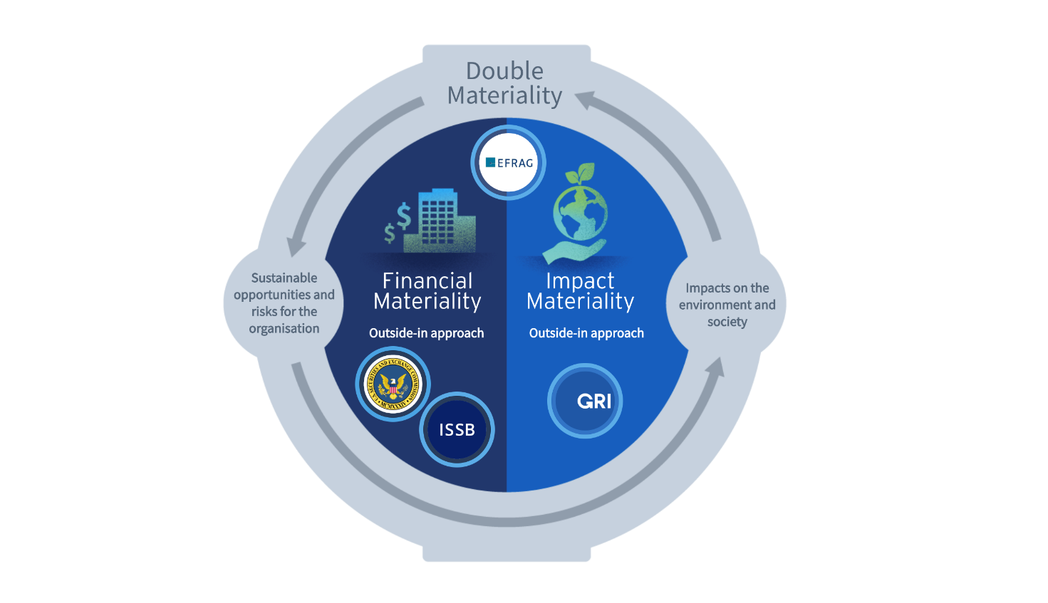
- The U.S. Securities and Exchange Commission (US SEC) and International Sustainability Standards Board (ISSB) define an ESG issue as material if it affects, or has the potential to affect, the cash flow and financial value creation of a company.
- According to Global Reporting Initiative (GRI), an ESG issue is considered material based on its impact on the environment, society, and economy, considering the organization's activities across the value chain.
- The European Financial Reporting Advisory Group (EFRAG) emphasizes the consideration of both financial and impact aspects of ESG issues, recognizing that a company can have an impact on, and be impacted by, such issues.

